Test Case: tc002_SPX_Dev5_Crear_Requisicion_Spot_Con_FAD_Tipo_Cobro_CC
Step 1 - Enter username and password and click to button Enter : Credentials Entered
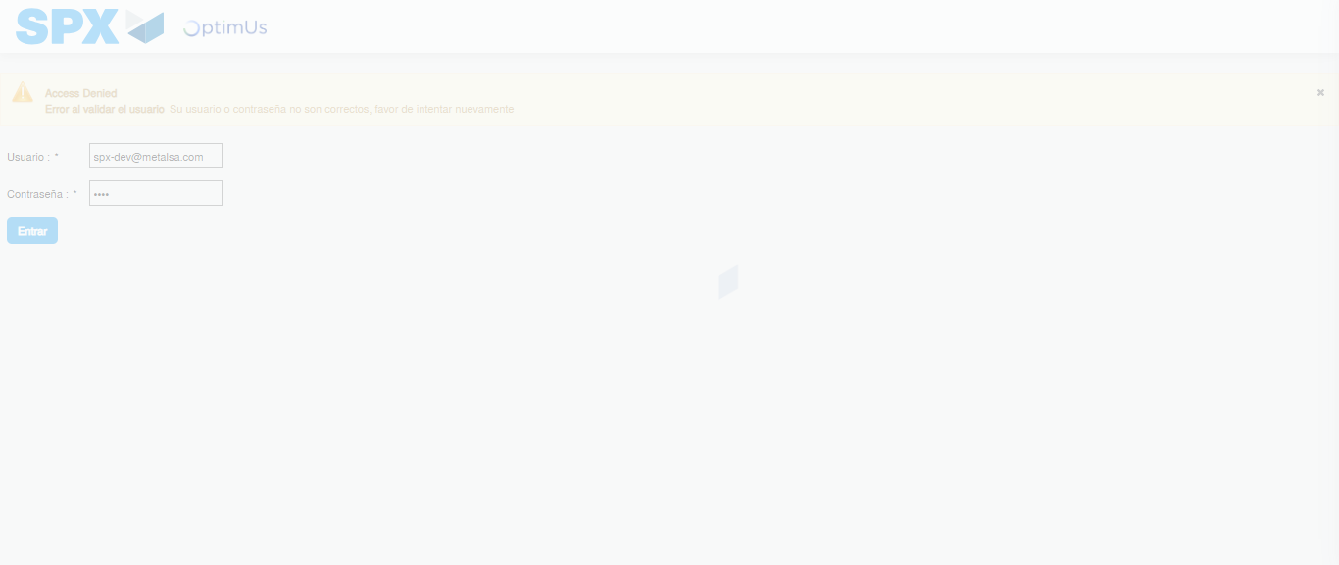Image file-name: QC_Testing-tc002_SPX_Dev5_Crear_Requisicion_Spot_Con_FAD_Tipo_Cobro_CC-1789485170314

Step 2 - Select to UEN and Access to Spot Buy Requisitions : UEN Correctly selected and Correct access
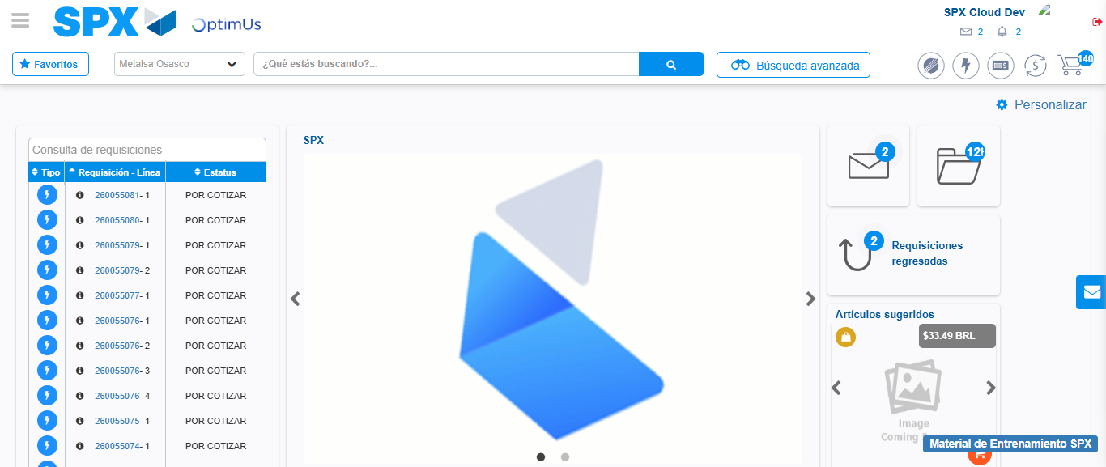Image file-name: QC_Testing-tc002_SPX_Dev5_Crear_Requisicion_Spot_Con_FAD_Tipo_Cobro_CC-1789485200478

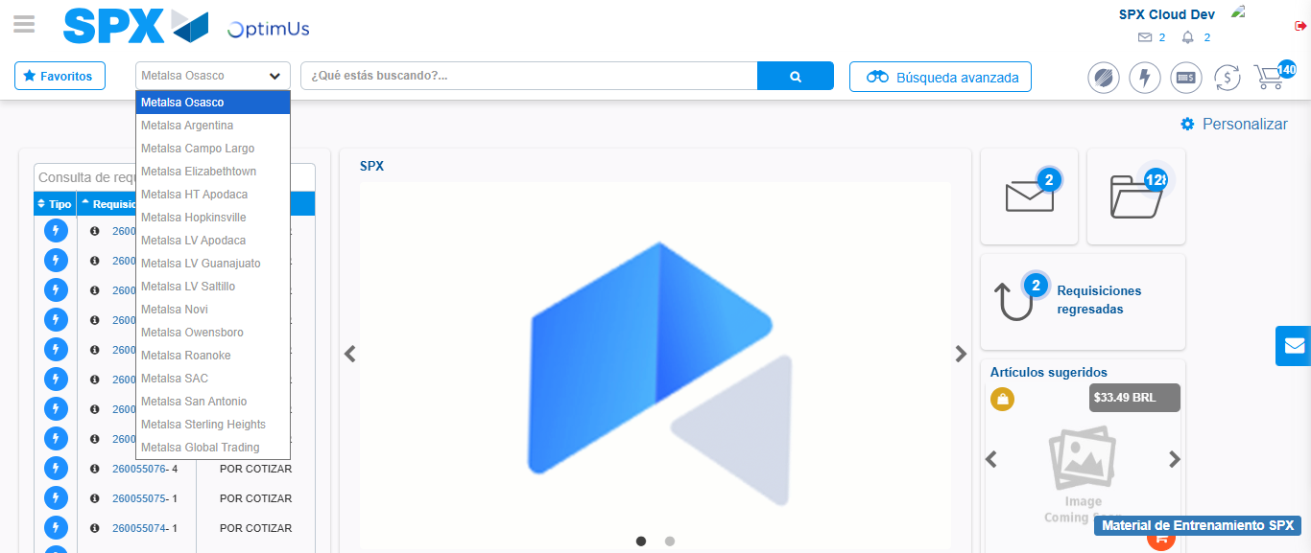Image file-name: QC_Testing-tc002_SPX_Dev5_Crear_Requisicion_Spot_Con_FAD_Tipo_Cobro_CC-1789485201164

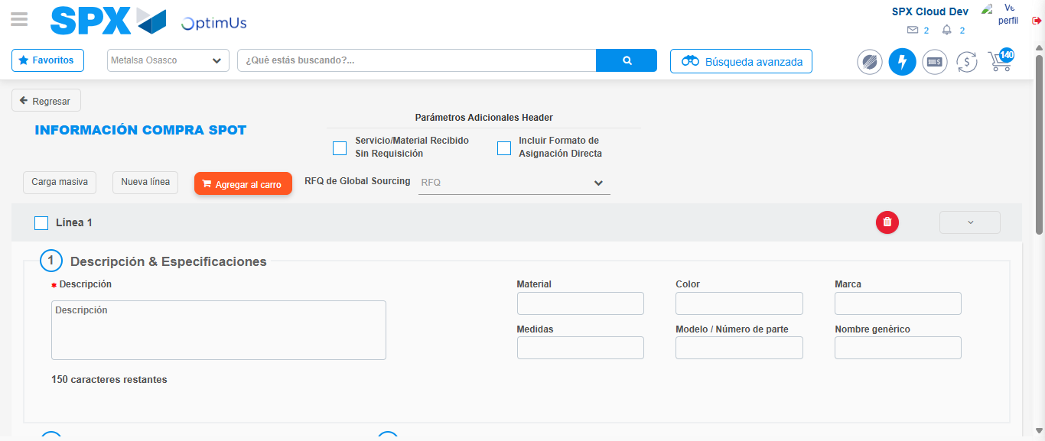Image file-name: QC_Testing-tc002_SPX_Dev5_Crear_Requisicion_Spot_Con_FAD_Tipo_Cobro_CC-1789485205771

Step 3 - Add FAD to Requisition: FAD Successfully Added
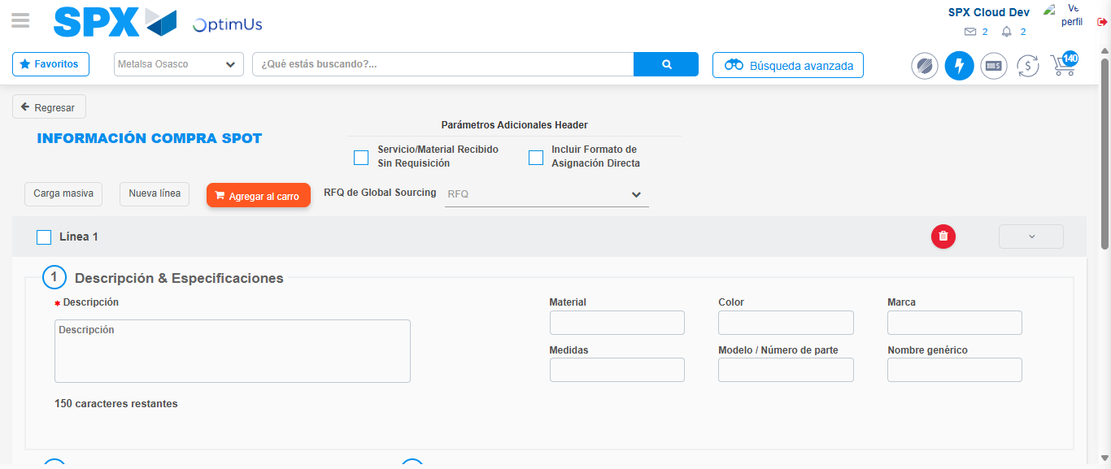Image file-name: QC_Testing-tc002_SPX_Dev5_Crear_Requisicion_Spot_Con_FAD_Tipo_Cobro_CC-1789485206050

Image file-name: QC_Testing-tc002_SPX_Dev5_Crear_Requisicion_Spot_Con_FAD_Tipo_Cobro_CC-1789485206262

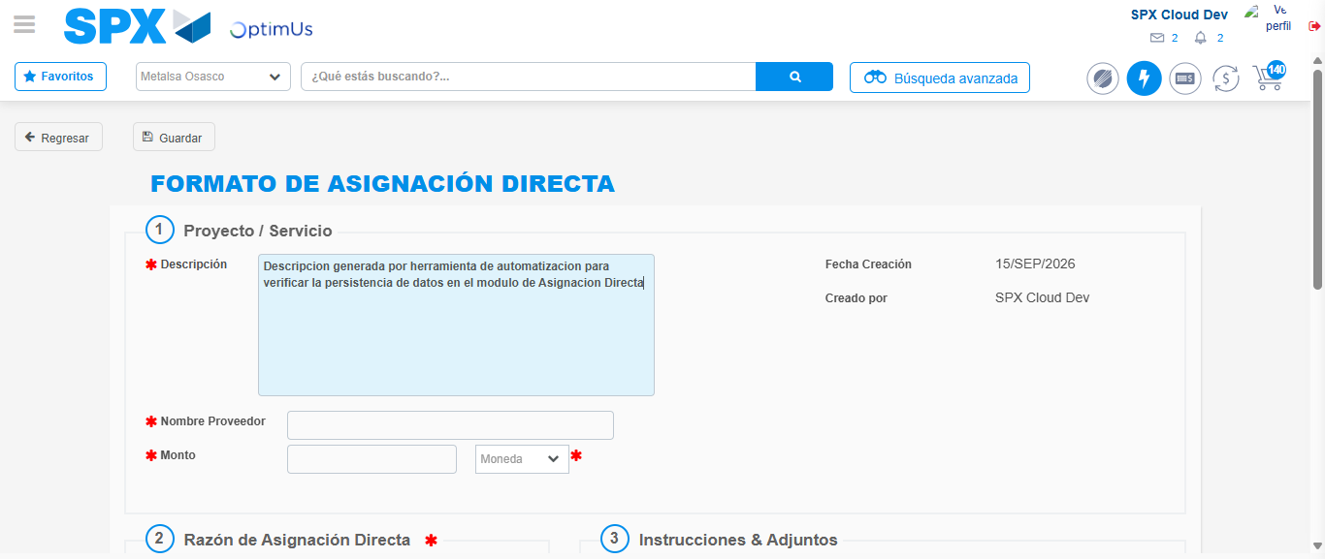Image file-name: QC_Testing-tc002_SPX_Dev5_Crear_Requisicion_Spot_Con_FAD_Tipo_Cobro_CC-1789485209177

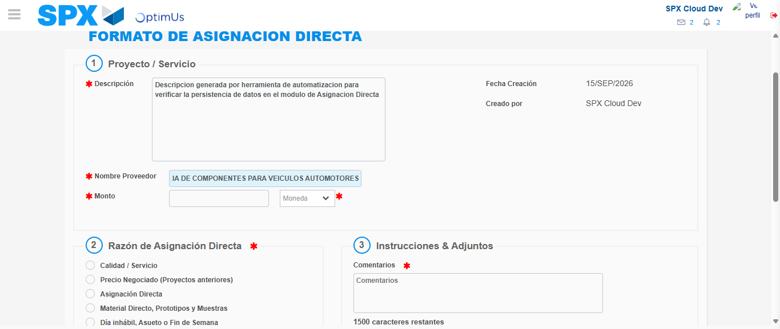Image file-name: QC_Testing-tc002_SPX_Dev5_Crear_Requisicion_Spot_Con_FAD_Tipo_Cobro_CC-1789485218717

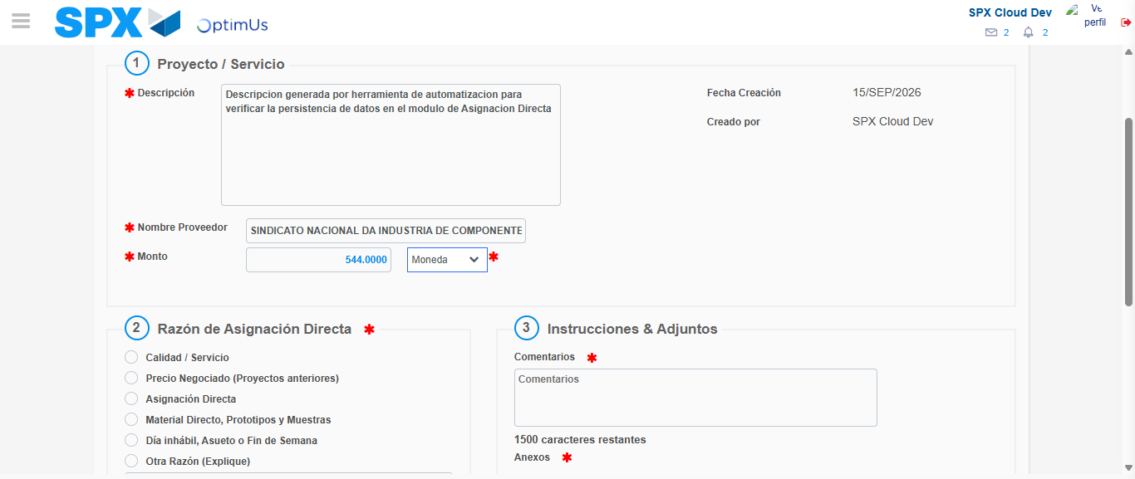Image file-name: QC_Testing-tc002_SPX_Dev5_Crear_Requisicion_Spot_Con_FAD_Tipo_Cobro_CC-1789485219148

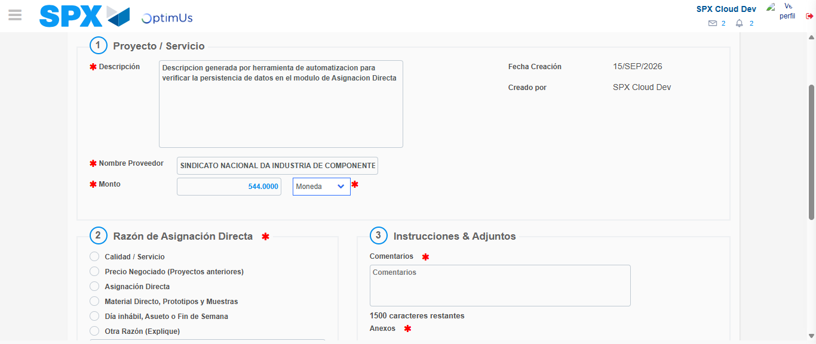Image file-name: QC_Testing-tc002_SPX_Dev5_Crear_Requisicion_Spot_Con_FAD_Tipo_Cobro_CC-1789485219365

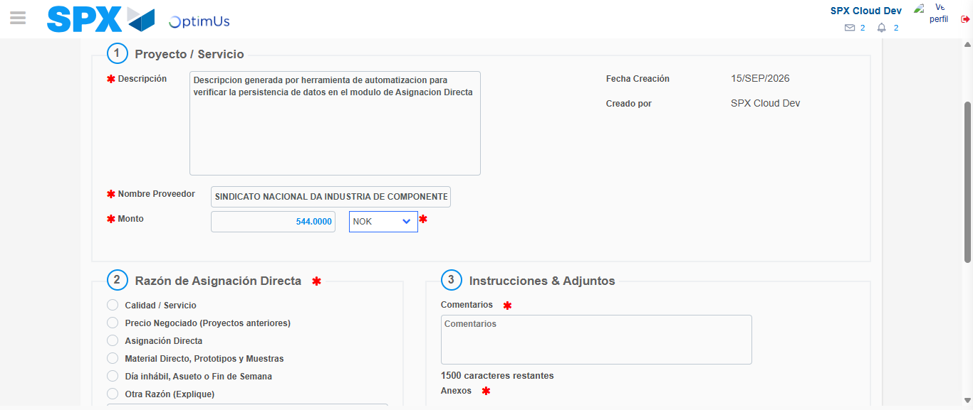Image file-name: QC_Testing-tc002_SPX_Dev5_Crear_Requisicion_Spot_Con_FAD_Tipo_Cobro_CC-1789485219790

Image file-name: QC_Testing-tc002_SPX_Dev5_Crear_Requisicion_Spot_Con_FAD_Tipo_Cobro_CC-1789485219995

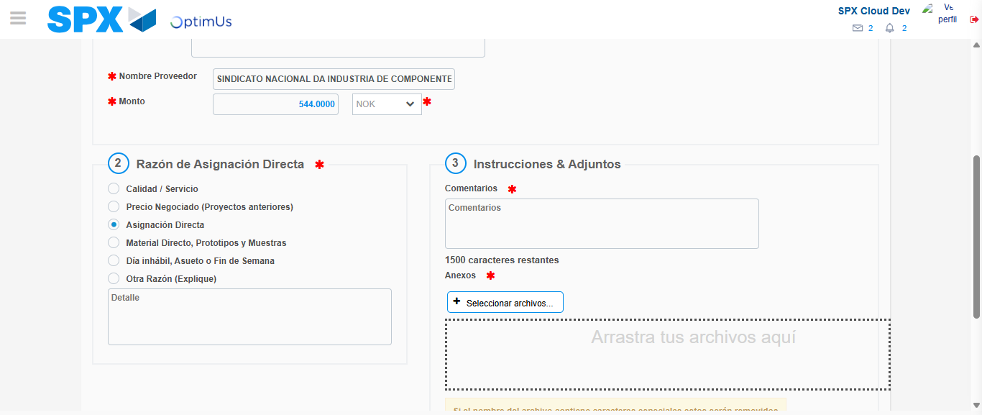Image file-name: QC_Testing-tc002_SPX_Dev5_Crear_Requisicion_Spot_Con_FAD_Tipo_Cobro_CC-1789485220885

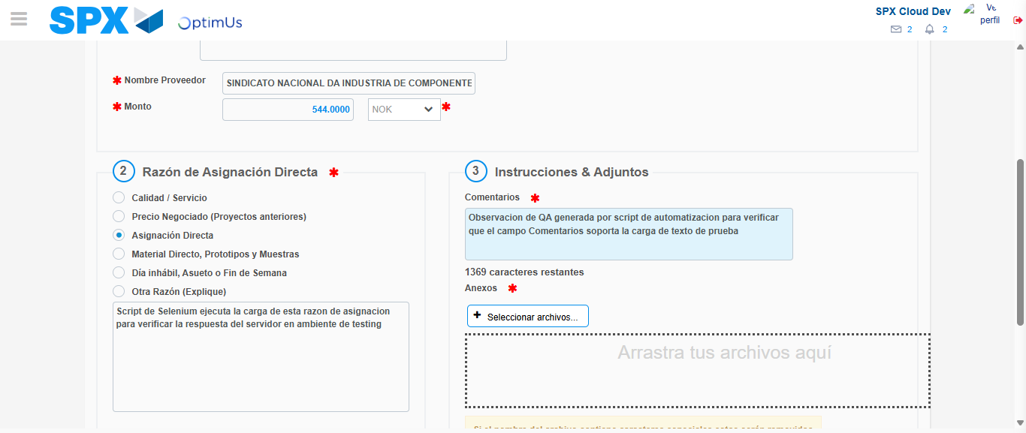Image file-name: QC_Testing-tc002_SPX_Dev5_Crear_Requisicion_Spot_Con_FAD_Tipo_Cobro_CC-1789485232178

Image file-name: QC_Testing-tc002_SPX_Dev5_Crear_Requisicion_Spot_Con_FAD_Tipo_Cobro_CC-1789485232876

Step 4 - Data Capture Spot Buy Requisition: Data captured correctly
Image file-name: QC_Testing-tc002_SPX_Dev5_Crear_Requisicion_Spot_Con_FAD_Tipo_Cobro_CC-1789485206050

Image file-name: QC_Testing-tc002_SPX_Dev5_Crear_Requisicion_Spot_Con_FAD_Tipo_Cobro_CC-1789485206262

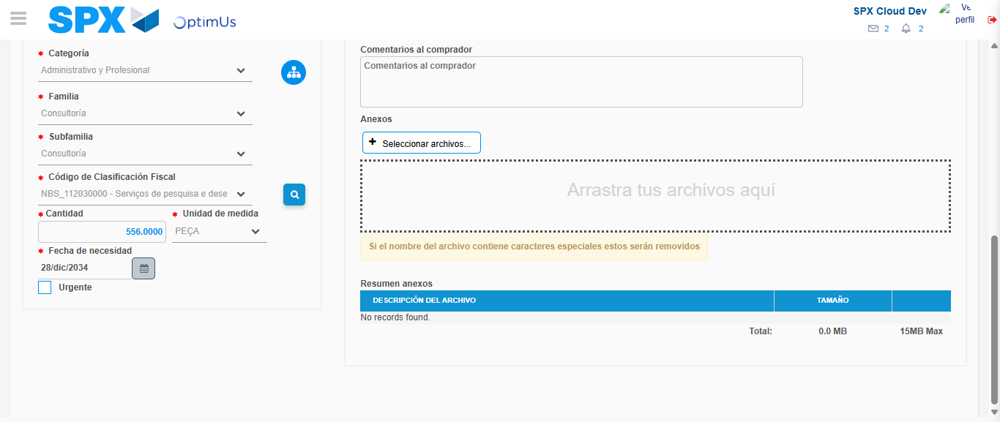Image file-name: QC_Testing-tc002_SPX_Dev5_Crear_Requisicion_Spot_Con_FAD_Tipo_Cobro_CC-1789485250672

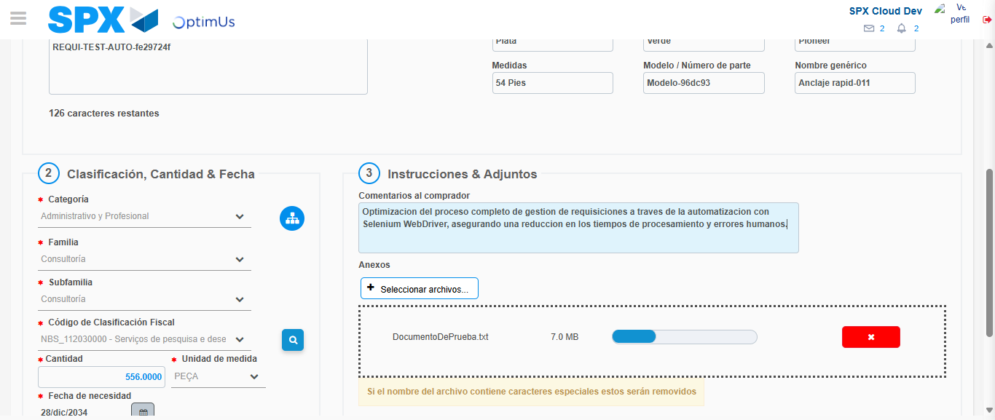Image file-name: QC_Testing-tc002_SPX_Dev5_Crear_Requisicion_Spot_Con_FAD_Tipo_Cobro_CC-1789485251638

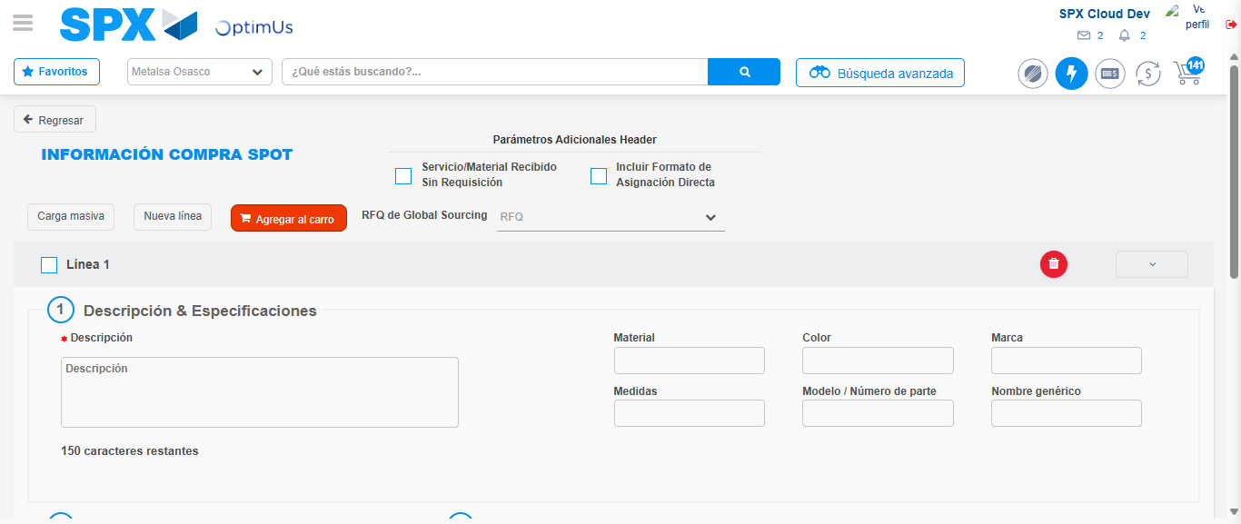Image file-name: QC_Testing-tc002_SPX_Dev5_Crear_Requisicion_Spot_Con_FAD_Tipo_Cobro_CC-1789485270608

Step 8 - Return to Main Page SPX : Return to Main Page SPX
Image file-name: QC_Testing-tc002_SPX_Dev5_Crear_Requisicion_Spot_Con_FAD_Tipo_Cobro_CC-1789485200478

Image file-name: QC_Testing-tc002_SPX_Dev5_Crear_Requisicion_Spot_Con_FAD_Tipo_Cobro_CC-1789485201164

Image file-name: QC_Testing-tc002_SPX_Dev5_Crear_Requisicion_Spot_Con_FAD_Tipo_Cobro_CC-1789485205771

Image file-name: QC_Testing-tc002_SPX_Dev5_Crear_Requisicion_Spot_Con_FAD_Tipo_Cobro_CC-1789485272873

Image file-name: QC_Testing-tc002_SPX_Dev5_Crear_Requisicion_Spot_Con_FAD_Tipo_Cobro_CC-1789485273059

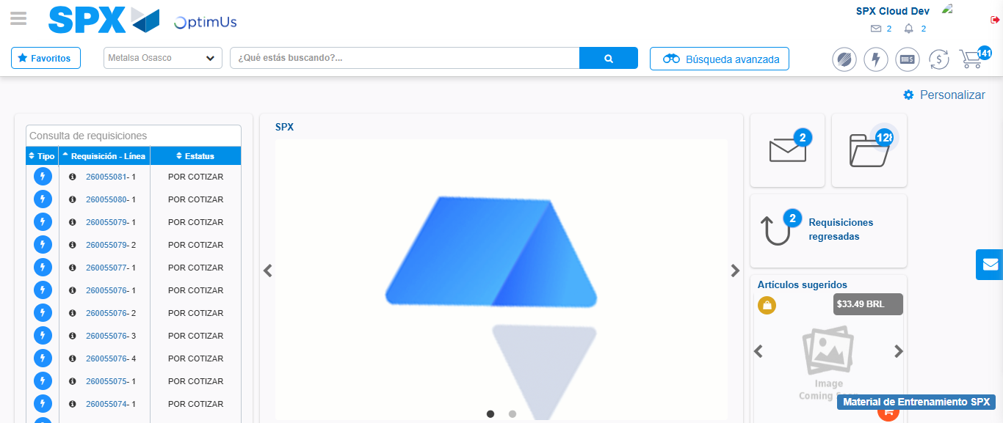Image file-name: QC_Testing-tc002_SPX_Dev5_Crear_Requisicion_Spot_Con_FAD_Tipo_Cobro_CC-1789485294411

Step 9 - Log Out : Log Out SPX
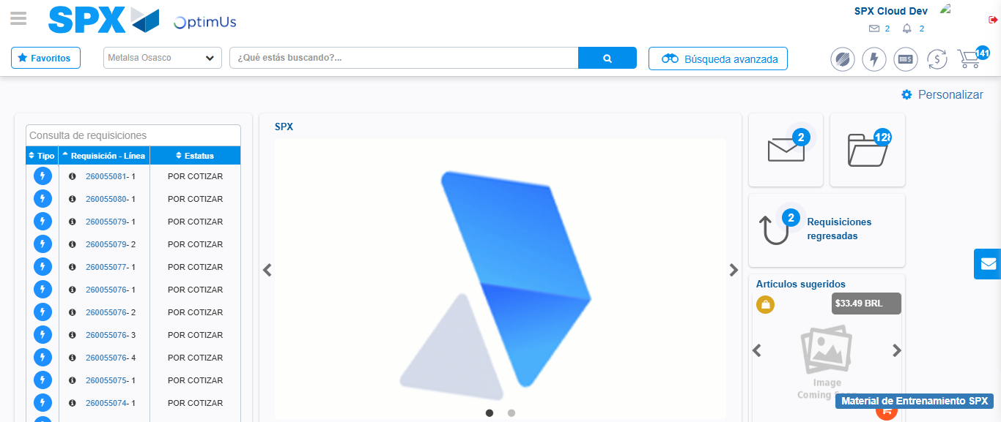Image file-name: QC_Testing-tc002_SPX_Dev5_Crear_Requisicion_Spot_Con_FAD_Tipo_Cobro_CC-1789485294743

